ASMFC FINAL EXAMINATION (11 Dec 2006)

SUMMARY OF ANSWERS

- The time series of the stock and recruitment indices indicate that the stock is in severe decline over the period from the late 70s to 1990, followed by a short period of stock rebuilding in the 1990s (Figure 1). The α and β parameters for the Beverton and Holt S-R model are 0.1910 and 0.1495 (Figure 2). A possible reference point for minimum stock level to avoid recruitment failure is 0.5 x 10⁶ kg.
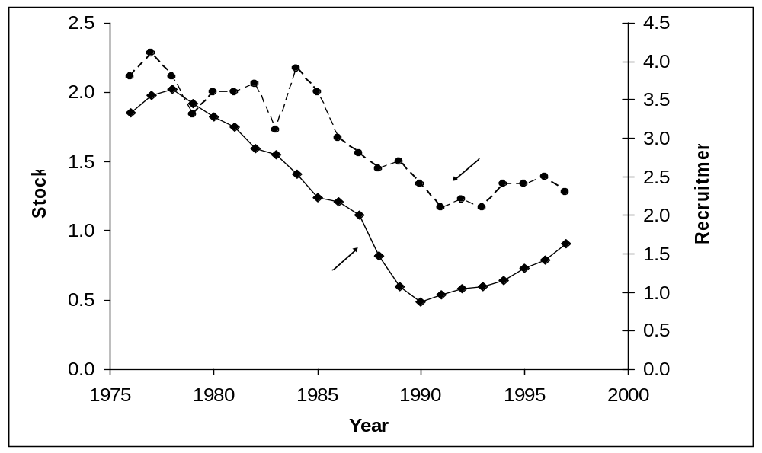
Figure 1. Stock-Recruitment time series.

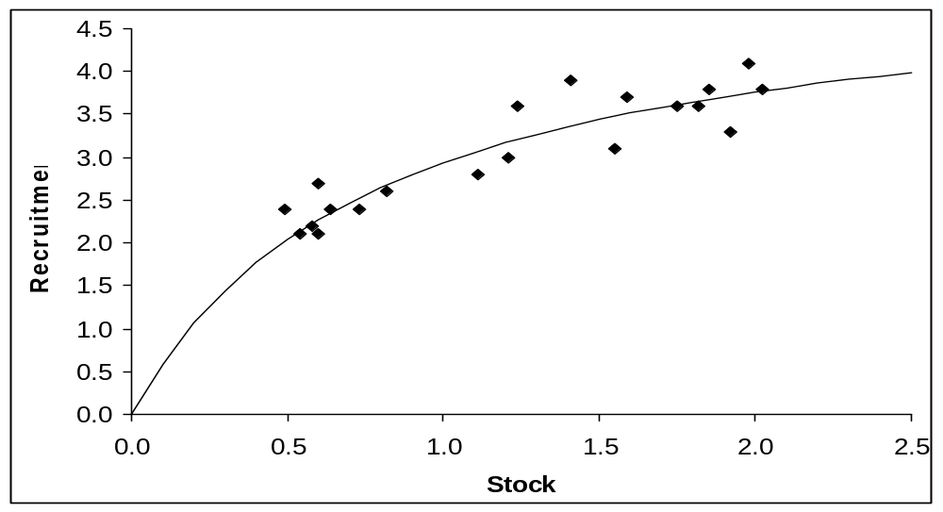
Figure 2 Beverton-Holt Stock-Recruitment relationship.

- YPR and SSBPR models (Figure 3). The target reference point to avoid growth overfishing is F_{0.1} and has the value of 0.21. The target reference point to avoid recruitment overfishing is F_{25%} and has the value of 0.45.
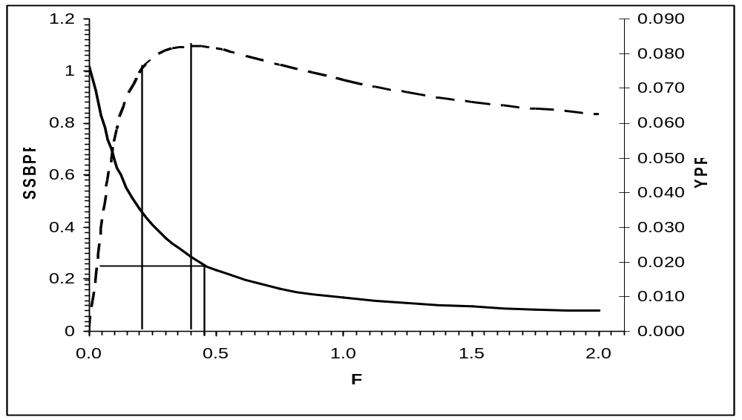
Figure 3. YPR and SSBPR models.

3. To integrate the Stock-Recruitment model with the YPR and SSBPR models, both models must refer to the same age recruits. Therefore the YPR and SSBPR models must be recalculated starting with age 1 recruits, rather than age zero recruits. While this does not change the reference point values because age 0 fish do not contribute to Yield or Spawning Stock Biomass, it will affect the actual values of Yield and Spawning Stock Biomass. The adjusted YPR and SSBPR curves are as follows:
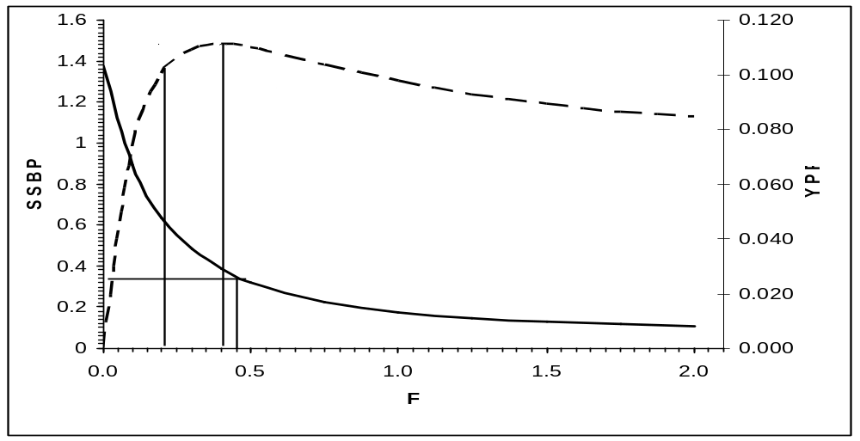
Figure 4. Revised YPR and SSBPR models
Combining the S-R relationship (based of the results of a VPA) and the SSBPR models (based on empirical biological and fishery data) results potential equilibrium points in the dynamics of the stock and the fishery at specific levels of fishing mortality (Figure 5).

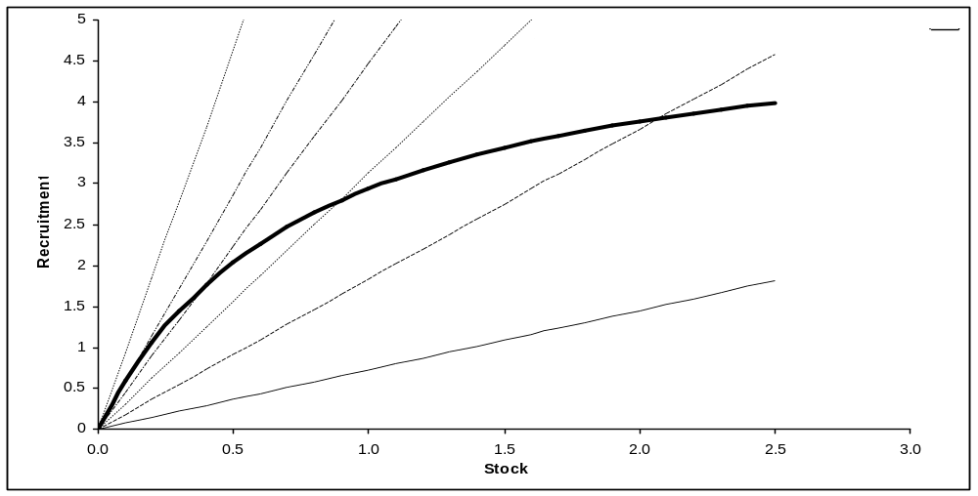
Figure 5. Combination of S-R relationships and revised SSB/R model

Combining the YPR model output with the S-R values at equilibrium allows for the estimation of total yield (Figure 6), and is maximized at an F level of 0.25 at 399 x10³ kg at SSB levels of 2070 x 10³ kg.
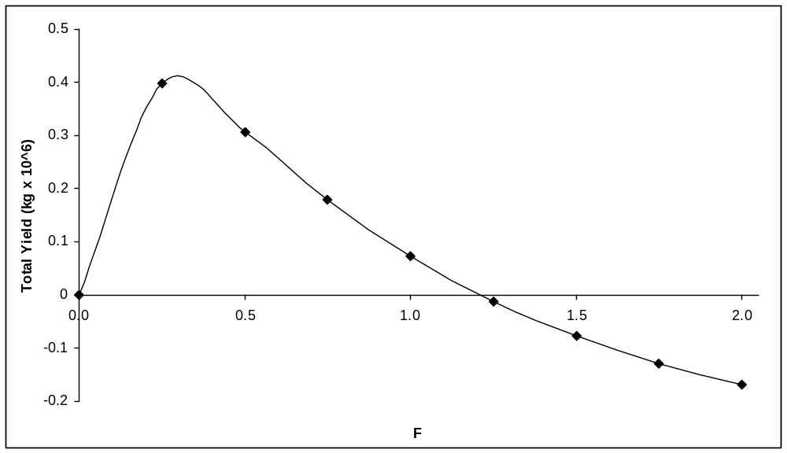
Figure 6. Total yield as a function of F.

4. The parameters estimated by the Graham-Schaefer formulation of non-equilibrium production model are r = 0.277 and K = 4694 (Figure 7). First note from the time series of effort catch and CPUE and that CPUE, a proxy for abundance is a five fold decline over the period 1975 to 1990, followed by a short period of stock rebuilding. The results of this production model for f_{MSY}, MSY and B_{MSY} levels are 0.426 x 10³ days, 321 x 10³ kg and 2347 x 10³ kg, respectively.
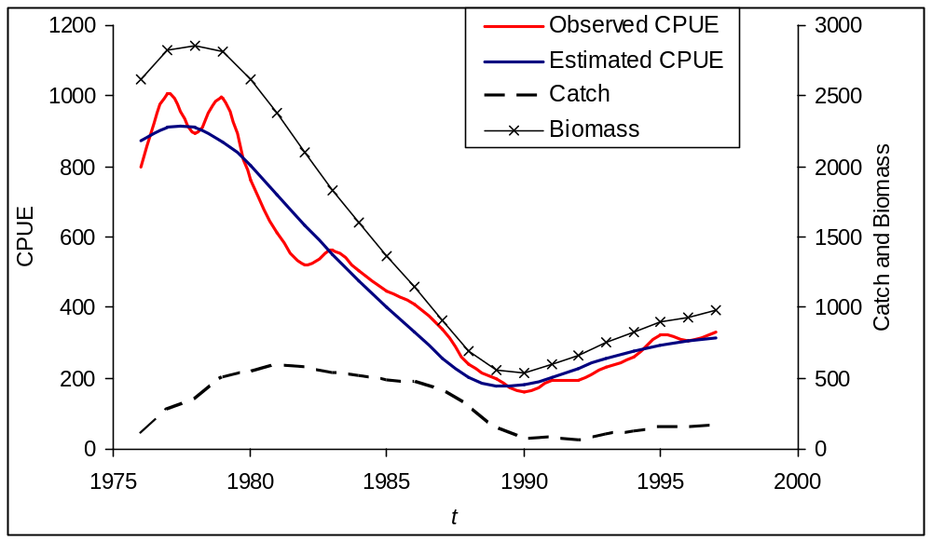
Figure 7. Results of the non-equilibrium production model.

An alternative analysis is the application of the equilibrium model by partitioning the data into the pre and post 1988/1989 period. Fitting the equilibrium model to the declining portion abundance trajectory results in an MSY estimate of 660 x 10³ kg, while fitting the same model to the rebuilding pages results in an MSY estimate of 227 x 10³ kg. Clearly the better analysis is the non-equilibrium model, however it is interesting to note the differences between that result and the results of the equilibrium model.

Additionally it is important to note the small discrepancy between the results of the integrated S-R and SSBPR and YPR models with the Biomass Dynamic model. The BD model estimated an MSY of about 20% less that of the integrated model. The discrepancy could be due to changes in the selectivity of the gear specified in the YPR-SSBPR model, that may not have been in use for the twenty year period used for input data for the BD model. For example if the age of entry into the fishery had been recently increased resulting in a higher YPR and SSBPR, then catch data in the BD model would have resulted in an underestimation of new MSY in the BD model.

- Summary and control law. Based on the history of the fishery as shown in Figure 8, the stock is in need of rebuilding and effort must be reduced. The target and limit reference points are 0.85 and 1.0 for biomass (Bt/B_{msy}) and 0.85 and 1.0 for effort (f/f_{msy}), respectively. The stock has been in the overfished condition and the fishery has been overfishing for many years. Potential options include shutting down the fishery, or dramatically reducing fishing effort for several years to allow for stock rebuilding. The YPR/SSBPR analyses should be redone to explore the potential benefit of increasing the age of entry into the fishery. After the stock has rebuilt, then reopen the fishery at a substantially lower level of fishing effort, perhaps 400 days per year.

Current catch levels are about 165 x 10³ kg with 500 days of effort. Based on the non-equilibrium production model, if the stock was rebuilt and the fishery managed at a f_{msy} limit of fishing mortality 425 days, the maximum sustainable catch would be 321 x 10³ kg, about twice the 1997 level of production, at stock levels of 2347 x 10³ kg.

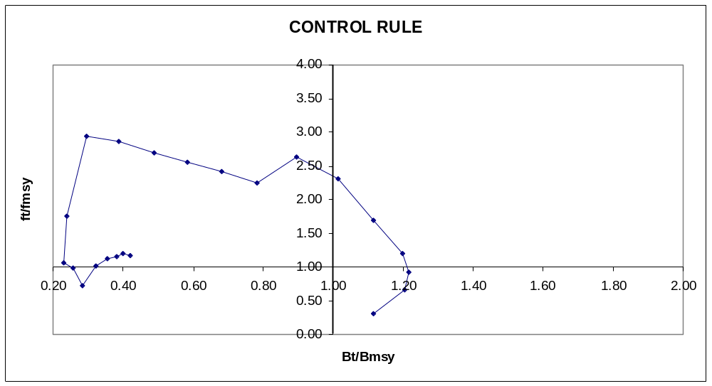
Figure 8. Control Law

